

American International University-Bangladesh (AIUB)
Department of Computer Science Faculty of Science & Technology (FST)
PROJECT TITLE
Society Problem Reporter and Analyzer
Submitted By Group 7
Semester-->Summer-25-26 |  | Section:T
SL | Student Name | Student ID
29 | 24-58655-2 | Sheikh Ahnaful Islam
31 | 24-58796-2 | Ayon Chowdhury
22 | 24-58220-2 | MD. Mezbah-Ul-Hossain Rahat
4 | 23-53306-3 | Md Rashed Musharof
3 | 23-52565-2 | Sabit Haan

3.3 Requirements Traceability Matrix
The following matrix maps each feature to its specification, screen definition, user story, and acceptance criteria, ensuring full traceability from requirement to implementation.

3.3.1 Functional Requirements
Requirement ID | Functional Requirement | Module | Priority
FR-01 | The system shall allow users (Citizen, Authority, Admin) to sign up by providing name, email, phone number, and password. | User Authentication | High
FR-02 | The system shall allow registered users to sign in securely using their email and password. | User Authentication | High
FR-03 | The system shall allow users to reset their password via a registered email if they forget their credentials. | User Authentication | Medium
FR-04 | The system shall allow citizens to report a local problem by providing a title, description, category, severity, image, and location. | Problem Reporting System | High
FR-05 | The system shall allow citizens to view a list of their submitted problem reports along with their current status. | Problem Reporting System | Medium
FR-06 | The system shall allow citizens to upvote problems reported by other users. | Citizen Voting System | High
FR-07 | The system shall display the total vote count for each reported problem. | Citizen Voting System | Medium
FR-08 | The system shall automatically calculate a priority score for each problem based on severity, vote count, and report time. | Priority Analyzer | High
FR-09 | The system shall rank and display reported problems in descending order of priority score. | Priority Analyzer | High
FR-10 | The system shall display a dedicated high-priority section on the authority dashboard for the most critical problems. | Priority Analyzer | Medium
FR-11 | The system shall allow authorities to view all reported problems with their details in a dashboard. | Authority Dashboard | High
FR-12 | The system shall allow authorities to update the status of a reported problem (Submitted / Under Review / In Progress / Resolved). | Authority Dashboard | High
FR-13 | The system shall allow citizens to view the full details and status history of their reported problem. | Problem Status Tracking | Medium
FR-14 | The system shall notify citizens whenever the status of their reported problem changes. | Problem Status Tracking | Medium
FR-15 | The system shall allow users to view their profile, including name, email, phone, and total reports submitted. | User Profile Management | Medium
FR-16 | The system shall allow users to edit and update their profile information. | User Profile Management | Low

Figma

Role : Citizen
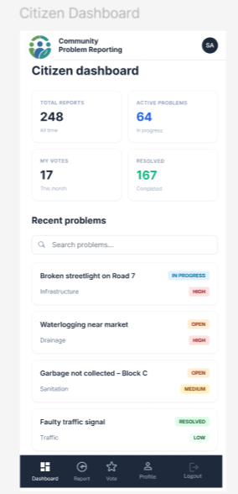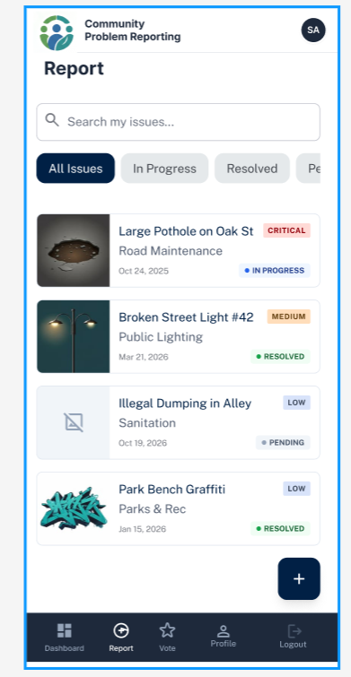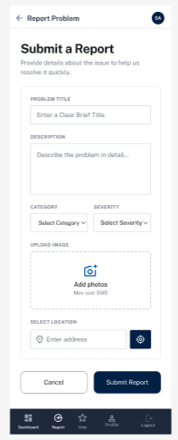
Figure: Citizen Dashboard Figure: My Reports Figure: Report Problem

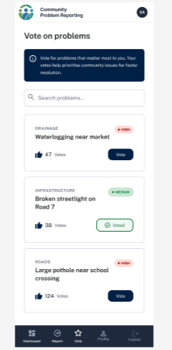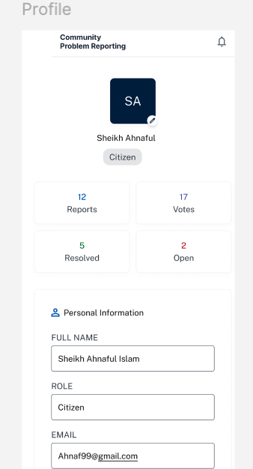
Figure: Voting Problem Figure: Profile

